Emotion Recognition in Disabled Individuals Through an Improved Assistive Communication System Based on Large Language Models and Ensemble Deep Learning
Amani Abdulrahman Albraikan¹, Nasser Allheeib², Malak Bakheet Alharbi³, Salihah Alotaibi4, Jahangir khan⁵, Haidar Almubarak⁶, Hanadi Alkhudhayr⁷, and Abdulbasit A. Darem^{8*}
1Department of Computer Sciences, College of Computer and Information Sciences, Princess Nourah bint Abdulrahman University, Saudi Arabia.
²Department of Information Systems، College of Computer and Information Sciences، King Saud University Riyadh 11495, Saudi Arabia.
3Department of Software engineering, College of Computer Science and Engineering, University of Jeddah, Saudi Arabia.
4Department of Information Systems, College of Computer and Information Sciences, Imam Mohammad Ibn Saud Islamic University (IMSIU), Riyadh 11432, Saudi Arabia.
⁵Department of Computer Science, Applied College at Mahayil, King Khalid University, Saudi Arabia.
⁶Department of Information Technology ، College of Computing and Informatics، Saudi Electronic University، Riyadh, Saudi Arabia.
⁷Department of Information Systems, Faculty of Computing and Information Technology, King Abdulaziz University, Rabigh 25732, Saudi Arabia.
8Center for Scientific Research and Entrepreneurship, Northern Border University, Arar 73213, Saudi Arabia.
* Corresponding author: Abdulbasitdarem_22@outlook.com

Abstract
Large language models (LLMs) and their variants have proven remarkable efficiency on several downstream natural language processing tasks. Disability remains a critical concern, continually creating obstacles. Disability can cause frustration as it is often perceived as a mental, physical, or cognitive impairment that constrains the individual’s development and social engagement. Therefore, considerable work has been dedicated to eliminating these sorts of constraints. These initiatives tackle the challenge that disabled individuals face. Individuals with disabilities frequently depend on others to satisfy their needs. Emotional detection is a vital research area that can depict numerous appreciated inputs. Emotion is conveyed differently by facial expressions, speech, gestures, and written text. Artificial intelligence models, such as machine learning, natural language processing, and computer vision, offer a framework through which non-verbal cues can be examined with a level of accuracy and reliability unparalleled by human observers. Furthermore, deep learning has garnered much attention in this domain. This study presents a Textual Emotion Recognition Using Large Language Model-Based Vectorization and Deep Learning Networks (TERLLMV-DLN) technique for Disabled Individuals. The aim of the proposed method is to provide an accurate and socially impactful solution for emotion recognition in accessibility-focused applications. To achieve this, the presented algorithm employs a comprehensive text preprocessing stage involving multiple steps designed to refine input data and maintain linguistic consistency. Following that, a large language model is used in the text vectorization process to generate high-dimensional semantic vectors. Lastly, an ensemble learning strategy is employed by integrating three powerful models namely temporal convolutional networks, stacked denoising autoencoder, and elman neural network for improving recognition precision. A broad array of simulation investigations is conducted to guarantee the improved solution of the proposed model. The comparative results reported the betterment of the proposed method over recent approaches in terms of various evaluation measures.
Keywords: Artificial Intelligence; Large Language Model; Textual Emotion Recognition; Assistive Communication; Disabled People; Natural Language Processing
1. Introduction
Non-verbal interaction plays a crucial part in human communication, affecting everything from social involvement to dramatic learning and exchange [1]. For persons, the capability for interpreting and responding to non-verbal signs is important to their emotional and social improvement. People with hearing disabilities face unique difficulties in this field because of their limited or absent auditory response, which can considerably affect their capability to obtain the intricacies of non-verbal interaction [2]. Nonverbal interaction includes various activities as well as gestures, body language, eye contact, facial expressions, and nearness. This leads to emotional frustration and social isolation, further aggravating the interaction gap [3]. Furthermore, hearing impairments can impact a person’s capability for regulating their emotional reactions, frequently owing to misinterpretation in a conversational context. They may respond unsuitably to social cues, either because they miss them completely or because they misunderstand them [4],[5]. This frequently results in distress and anxiety, which can be obvious as behavioural outbursts or withdrawal, confusing their communication in both individual relationships and academic institutions.
The abilities of large language models (LLMs) are quickly developing, making novel opportunities for user applications ranging from chatbots to digital appliances to writing assistance [6]. Though LLMs allow a variety of helpful applications, current work has underlined ethical problems encompassing their development and utilization. The studies have concentrated on how LLMs consider the societal biases rooted in the information that they are trained on, flexible model activities that could reinforce stereotypes and reject users from traditionally marginalized people [7]. There is a wide variety of scholarship exploring fairness in technical languages, considering ethnicity/race, age, and gender. Currently, this study has been expanded to education justice for persons with disabilities, involving availability examinations and considerations of harmful linguistic norms that may continue. Furthermore, Artificial Intelligence (AI) became an essential tool in improving the interpretation and comprehension of non-verbal interaction, proposing intense abilities particularly valued in contexts including persons with language disorders like loss of hearing [8]. AI approaches such as natural language processing (NLP), computer vision (CV), and machine learning (ML) offer a structure through which non-verbal signs can be examined with a level of accuracy and reliability unmatched by human witnesses. This study aligns with the emerging direction of visual computing by leveraging AI and deep learning for perception-oriented emotion understanding. The proposed framework contributes to intelligent content analysis and human-centered interaction, which are central to modern visual computing systems.
Moreover, developments in ML can translate to support for individuals with hearing impairments. Latest advances show that these methodologies offer tailored responses to the specific issues these societies face [9]. Furthermore, deep Learning (DL) has developed. It is a set of techniques and models with high-level summaries through a framework developed by various non-linear alterations. DL method uses various information for extracting features spontaneously, focusing on imitating the human brain’s ability for observing, analyzing, learning, and making an inference, especially for enormous, multiple difficulties. The DL model generates relations above immediate neighbours in information and creates learning patterns, eliminating representations exactly from information without human interference [10]. This study proposes an attention-driven deep learning method (F-CAM) using only image-wise labels to automatically localize and emphasize regions of interest in DVR-based medical volume visualization, outperforming existing methods on PET-CT and MRI datasets [11]. This study introduces a Local-to-Global Latent Diffusion Model (LG-LDM) with a Facial Denoiser Model (FDM) and an Emotion-centric Vector Quantized-Variational AutoEncoder (EVQ-VAE) to generate emotionally realistic 3D facial animations from audio synchronization, addressing the limitations of neutral-expression animations in augmented and mixed reality applications [12].
1.1. Paper Contribution
This study presents a Textual Emotion Recognition Using Large Language Model-Based Vectorization and Deep Learning Networks (TERLLMV-DLN) technique for Disabled Individuals. The main contributions of this study are:
- The main objective of the TERLLMV-DLN is to provide an accurate and socially impactful application for emotion recognition in accessibility-focused applications.
- To achieve this, the TERLLMV-DLN algorithm leverages a comprehensive text preprocessing stage to enrich input data and maintain linguistic consistency.
- Furthermore, a large language model (LLM) is utilized in the text vectorization process for creating high-dimensional semantic vectors.
- At Last, an ensemble learning strategy is employed by integrating three powerful models, namely temporal convolutional networks (TCN), stacked denoising autoencoder (SDAE), and elman neural network (ENN) for refining recognition precision.
- The comparative analysis stated the betterment of the TERLLMV-DLN technique on recent approaches in terms of various evaluation measures.
1.2. Paper Structure
The manuscript structure is as follows: Section 2 surveys prior studies on textual emotion recognition using an LLM. Section 3 elaborates on the presented TERLLMV-DLN methodology, and Section 4 showcases investigational outcomes. Lastly, in Section 5, conclusions are outlined.
2. Existing Research Works on Textual Emotion Recognition
This section provides existing research works on textual emotion recognition. [13] introduced explainability methods for binary deep neural architectures in the context of emotion classification across video analysis. The major influence of this research involves the service of a new explainable AI method for comprehending the critical facial landmarks actions characteristic of emotional feeling, employing this data to enhance the presentation of DL-driven emotion classification. [14] intended an Arabic Mood Changing and Depression Detection utilizing Artificial Hummingbird Optimizer method with DL (AMCDD-AHODL) approach for visually challenged persons. This proposed method detects various types of depression and emotions employing Arabic tweets. Moreover, the approach uses a hybrid LSTM-BiGRU method for the classification and recognition approaches. [15] suggested the developing domain of context-driven emotion recognition by utilizing psychological theories of human emotion insight to inform the intent of the automatic technique. This method integrates emotion recognition approaches with Bayesian Cue Integration (BCI) for combining emotion inferences from uncontextualized facial expressions and context of knowledge implied via LLM. For testing this method in the context of understanding facial expression throughout a social task.
[16] proposed a multiple-column CNN with leaky ReLU activation function on the EEG brainwave. Many scalp electrode locations are employed for collecting EEG signals, and every electrode provides spatially unique information. This leads to the possibility of a method for identifying emotions employing the spatial data in EEG information. [17] proposed a new transformer called emotion transformer (EmT). EmT is intended for improving both simplified cross-subject electroencephalography (EEG) emotion regression and classification tasks. An innovative residual Multiview pyramid graph CNN (RMPG) method is then presented for learning dynamic graph representations for every EEG characteristic graph through sequence, and feature representations of every graph are merged into a signal unit. [18] proposed a salp swarm algorithm with deep RNN-driven textual emotion analysis (SSADRNN-TEA) approaches for visually impaired people. This article assumes preprocessing for making the input information consistent with the final phases of processing, and the BERT word insertion method is used.
[19] presented the AI methods for automatic detection of individual emotions, allowing a machine (i.e., a chatbot) for precisely evaluating the emotional conditions of a human and for adapting the interaction appropriately. The whole automation of this process is yet an issue. These variations can be fully addressed with an ML method that depends on automatic learning from knowledge signified by the text information from discussions. [20] suggested an automatic emotion recognition method that depends on DL utilizing electroencephalogram signals. A lightweight pyramidal 1-dimensional CNN method is presented that includes a minor amount of learnable parameters. Employing the method, a twin-level ensemble classification is intended. Every channel is examined gradually at the initial level for generating forecasts that are merged based on the most votes. Another level merges the forecasts of all the channels of a signal, employing the most votes for predicting the emotional condition. Vasamsetty et al. [21] integrated time-series, wearables, CDSS, medical imaging, and voice diagnostics, achieving 94% accuracy for geriatric chronic care. Their multi-modal fusion inspires our attention-driven method, extending their work with automated visual emphasis for improved ROI localization. [22] proposed a novel VideoQA model called Text-Assisted Spatial and Temporal Attention Network (TASTA) that explicitly learns attention for selecting relevant visual information to answer questions about videos. TASTA is simple, small, clean, and efficient, succeeding mainly through two new strategies for better utilizing textual information. Experimental results on the TGIF-QA dataset demonstrate its significant superiority over state-of-the-art methods, and ablation studies confirm the effectiveness of its key components. [23] proposed the FCAGAN model for cross-lingual font style transfer using limited samples. A full-domain convolutional attention module, adaptive fusion mechanism, and multi-level feature extraction approach are utilized to improve multilingual font style learning and preserve character integrity. Recent works highlight the growing convergence of AI, vision, and perception-driven analysis in emotion recognition tasks. This study builds upon such interdisciplinary trends by focusing on AI-driven semantic understanding within assistive communication systems. Several research works on emotion analysis systems for disabled individuals have been presented in Table 1.
Table 1 Outline of existing emotion analysis systems
References | Objectives | Approaches | Outcomes
[13] | To investigate and explainability models for a dual network framework in the classification of emotion by recognizing videos. | Explainable artificial intelligence (XAI) and Deep Neural Network (DNN). | Achieves an accuracy of 8% and 6%.
[14] | To project a novel method intended to emotionally unbalanced individuals primarily aiding VIP. | LSTM model, Bi-GRU, Artificial Hummingbird Optimization (AHO), and Wave Net model. | Accuracy value of 95.80 %
[15] | Aimed to decontextualized signals, and highlighting the significance of context in emotion perceptions. It develops a region of context-based emotion identification by utilizing the psychological theory of human emotion perception by informing an automated model. | LLM | Achieves better performance.
[16] | To recognize spatial correlation and eliminate features that represents the spatial distribution of brain activity by utilizing a multiple-column CNN that concurrently process signals from multiple channels. This creates it probable for the method to identify emotions utilizing the spatial data in EEG. | Multiple-column CNN | Accuracy of 98.10% and 81%.
[17] | Intended to learn multi-level and multi-view graph embeddings utilizing many learnable adjacency matrices. This method integrates knowledge of neuroscience, identifying that emotion contains numerous fundamental cognitive processes. | Transformer model | Accuracy of 0.802 and 0.595.
[18] | Aimed to classify and identify of emotions for disabled persons and endures pre-processing and word embedding | BERT, Deep RNN (DRNN), and SSA. | Accuracy of 99.26
[19] | To project AI methodology for automatically recognizing human emotions, allowing a machine to precisely evaluate the emotional state of humans and to familiarize its communication. An overall automation procedure is still facing challenges. | ML and DL approaches. | F1-score of 0.95
[20] | A lightweight pyramidal network is presented that entails a smaller count of learnable parameters. Utilizing the method, a dual-level ensemble classifier has been intended, and all channels are scanned incrementally in the primary level to generate a prediction that is fused utilizing the majority of votes. | 1D-CNN model | Accuracy of 98.43% and 97.65%.

3. Materials and Methods
In this study, a TERLLMV-DLN model is proposed for Disabled Individuals. The purpose of the presented TERLLMV-DLN method is to provide an accurate and socially impactful solution for emotion recognition in accessibility-focused applications. For that motive, the proposed TERLLMV-DLN model involves text preprocessing, text vectorization using LLM, and classification models. The proposed methodology reflects the integration of AI models for advanced content representation and perception analysis. Such integration is aligned with modern visual computing paradigms that combine learning-based representations with intelligent interpretation mechanisms. Fig. 1 portrays the overall diagram of TERLLMV-DLN methodology.
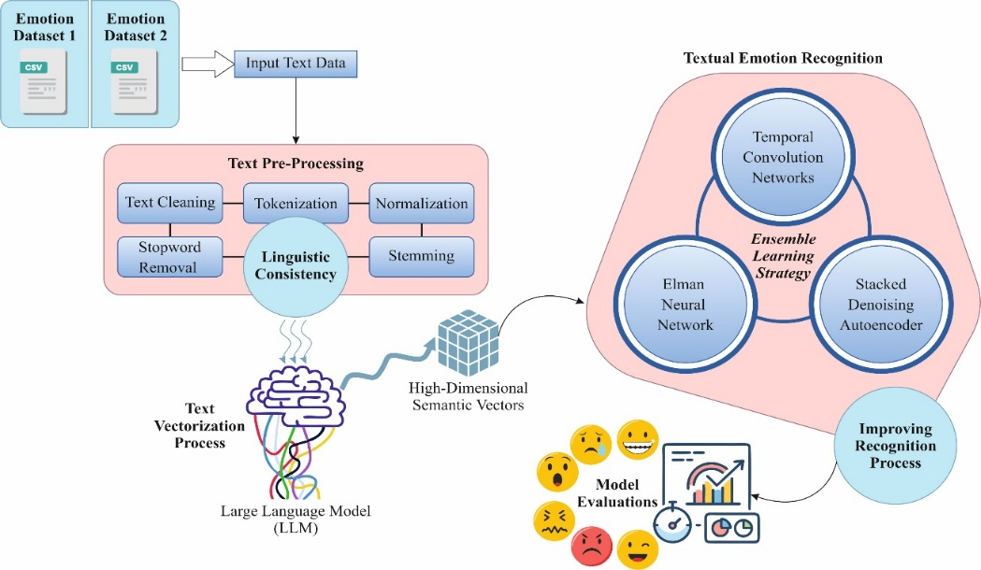
Fig. 1 Overall diagram of the TERLLMV-DLN approach
3.1. Text Preprocessing
Initially, the proposed TERLLMV-DLN algorithm utilises a comprehensive text preprocessing stage comprising numerous steps designed to improve input data and maintain linguistic consistency [24].
- Text Cleaning: This procedure eliminates non-alphabetic characters, like punctuation marks (except underscore), numbers, emojis, mentions, and irrelevant symbols. Here, data cleaning should be performed because this procedure impacts the quality of data that will be employed. Furthermore, cleaning also aids the method of execution and offers optimum solutions so that the objective of the research is sufficiently accomplished.
- Tokenization: It has an NLTK library that splits every text into single-word units like tokens. It aids to comprehend and examine text by dividing data into additional manageable segments. Tokenization is performed in more depth and offers better insight into how the data is utilized.
- Normalization: The phase of text normalization is technically executed by converting text into lowercase letters and correct non-standard or inappropriate spelling. Text normalization is to eliminate punctuation marks, rearrange words, or spelling correction. The word turns benchmark for word repairing contains a word repair dictionary database that is employed to repair words that are tokenized.
- Stop word Removal: This phase eliminates common words that have no special meaning in topic analysis, like "dan” (“and”), “atau” (“or”), “itu” (“that”). The stop words are not eliminated comprising “tidak” (“no”), “belum” (“yet”), “bukan” (“not”), “namun” (“however”), “daripada” (“than”), “sebelum” (“before”), “sedangkan” (“while”), “kecuali” (“except”), “selain” (“besides”). Few removed words are modifying the meaning and data of the sentence as some have a significant role which integrated with another sentence. Thud, customization is performed to modify the pre-processing to suit this analysis.
- Stemming: Stemming converts a word into its base form. When words are reduced to their root form through stemming, some results may be invalid due to limitations in the base language used. Stemming is leveraged in the scenario of NLTK and Sastrawi. It comprises Tokenization, text pre-processing, and other available features.
3.2. LLM-Driven Text Vectorization
Then, an LLM is employed in the text vectorization process to create high-dimensional semantic vectors. The first main process of the proposed method is to transform the semantics of text-based scale objects into an assessable format [25]. It is attained by converting the text into a mathematical representation known as embedding. In the contextual of LLM, embeddings are higher-dimensional vector representation, which seize text semantic meaning, allowing contrast across dissimilar texts. LLM, like GPT3, depends upon transformer structures that trust on self-attention mechanism for handling text. When a text input is delivered to LLM, the method pauses it into small units (tokens).
Every token is drawn to a primary embedding vector from a learned language. Then, the transformer layer enhances these embeddings by upgrading them over a feed-forward neural network and an attention mechanism. In this procedure, every token’s embedding was attuned depending on its context link with other tokens in a sequence of input. The last output embedding summarizes an individual word's meaning and its semantic relationship in the given contextual. Selection of a correct LLM is vital in that embeddings are produced by these methods that rely on innovative neural network structures. In contrast, LLMs with high-dimensional embeddings were stated for capturing multi-faced semantic meaning, like user performance and concept activation. As OpenAI’s released method, GPT3's large method dimension and dissimilar pre-training permit it to seize richer semantic relationships than techniques such as BERT, which is crucial for redundancy recognition. In addition, the study exhibited that embedding’s produced by the BERT method were considerably distant from validation, while GPT3 formed more consistent groups that aligned superior with theoretical paradigms. So, for embedding generation, we select the GPT3 large method as the LLM in the proposed method. Fig. 2 portrays the structure of LLM.
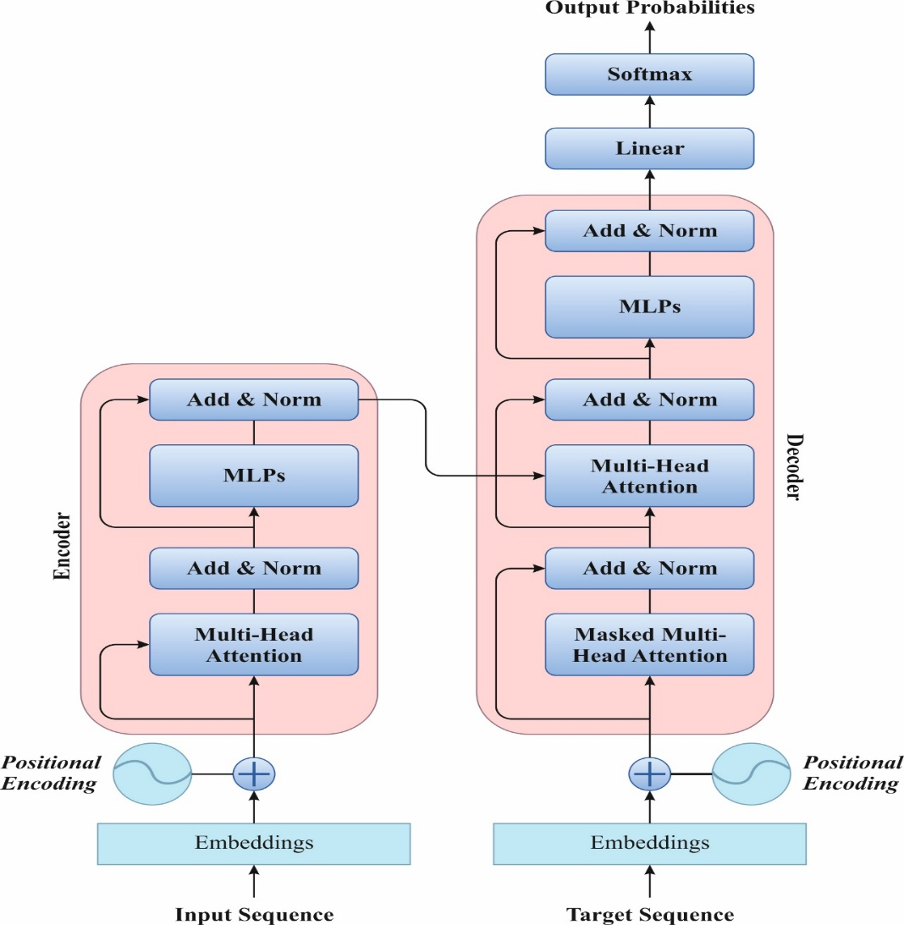
Fig. 2 Architecture of LLM
3.3. Ensemble Classification Model for Emotion Recognition
Finally, an ensemble learning strategy is employed by integrating three powerful models, namely TCN, SDAE, and ENN, to improve recognition accuracy.
3.3.1. Temporal Convolutional Network
TCN depends on the structure of CNN, particularly employed to manage time-series data [26]. It employs dilated and causal convolutions to effectually acquire long‐range dependency in sequences, whereas alleviating problems relevant to gradient vanishing and exploding.
Causal convolution
Causal convolution is designed to evade the utilization of upcoming data that depends on past and existing data. Classical convolutions, while calculating outputs, taking into account upcoming inputs that disrupt the basic idea of time-series modeling “the existing state relies on the past.” Causal convolution tackles to slide the convolution kernels in the backward direction, maintaining the sequence of temporal causality. Assume that input depicts $x=\{x_{1},x_{2}, …,x_{T}\}$, with a length of the convolution kernel $k$. Now, 1D causal convolutional, the resultant outcome $y_{t}$ at certain time-step $t$ is specified.
$y_{t}=\sum_{i=0}^{k-1}{f}\left(i\right)⋅x_{t-i^{'}}t=k,k+1, …, T$ (1)
Let $x_{t-i}$ denotes the input at $i_{th}$ time-step previously existing time point $t$ and $y_{i}$ signifies $t_{th}$ element of convolution resultant order and $f(i)$ signifies $i_{th}$ parameter of convolutional kernel. While $t<k$, padding was implemented by assuring the input of convolutional kernel.
Dilated convolution
Dilated convolutions contain the dilation factor $d$ is presented. To skip a static count of $d$ time-step as the slides of the convolutional kernel, the receptive area rises exponentially whereas keep the depth of the network and number of parameters approximately unchanged. It enables the method to acquire long‐range temporal dependency with a shallow network.
$y_{t}=\left(x*df\right)\left(t\right)=\sum_{i=0}^{k-1}{f}\left(i\right)⋅x_{t-d⋅i}$ (2)
Now $t=d(k-1)+1,d(k-1)+2,…,T$, and $d$ signifies the factor of dilation. While $d=1$, decreases the standard causal convolution. By maintaining causality and safeguard position among kernel and input, $d(k-1)$ zeros were padded to sequence on the left side.
Residual connection
To improve the steadiness of training and the representation capability of the deeper network, TCN integrates a module of residual connections. A deeper network frequently facing challenges like degradation or vanishing gradients. The residual framework presents an identity mapping pathway, enabling gradients to directly propagate previous layers, thus lessening complexities and enhancing the performance of the network. Assume that input is $x$ and the non-linear mapping function in the residual module $F(∙)$ and residual out put $r$ is specified.
$r=σ\left(F\left(⋅\right)+x\right)$ (3)
Where $σ$ signifies the non-linear activation function. The function $F(∙)$ contains a dual sequential layer of dilated causal convolution, normalization operation and activation function. The residual link allows the production of deep TCN structure, while every layer can adopt a diverse dilation factor $d∈1,2,4,…$. It enables the network by accomplishing an exponentially increasing receptive area whereas keep the parameter counts, thus effectually modeling long‐range temporal dependency.
3.3.2. Stacked Denoising Autoencoder Architecture
AE is primarily employed for lessening dimensionality, data pre‐processing, clean dataset generation, and removing noise from data. AE contains an encoding and decoding that contains an input, output layers, and hidden layer (HL) [27]. During this framework, the encoder converts the input data into hidden representation in HL. Removal of intricate non-linear features and generation of novel clean database by gaining vector features that constitute the primary architecture of input data is important features of AE. In the structure of AE, the encoder and decoder operations for input $x$ are executed:
$h=f\left(W_{1}x+λ_{1}\right)$ (4)
$y=g\left(W_{2}h+λ_{2}\right)$ (5)
Here $W_{1}$and $W_{2}$ refers to the weight of encoding and decoding networks, $h$ denotes the hidden representation, $y$ signifies the output. The bias of HL and output layer denotes $λ_{1}$ and $λ_{2},$ correspondingly. Likewise, $g$ and $f$ indicate activation functions.
The computation of reconstruction error $L_{AE}$ for $n$ input instances are specified.
$L_{AE}=\frac{1}{n}\sum_{i=1}^{n}{(}x_{i}-y_{i})^{2}$ (6)
SDAE is presented to enhance the execution of AE. The DAE model contains every feature of AE and varies from AE only input. DAE implements a variant of input to the layer of input. The version $\tilde{x}$ of the input vector $x$ has been created by stochastic mapping, and subsequently $\tilde{x}$ given as input:
$\hat{y}=f_{θ}\left(\tilde{x}\right)=s\left(W_{1}\tilde{x}+λ_{1}\right)$ (7)
Here $f$ and $\hat{y}$ denotes encoder mapping and hidden illustration, correspondingly. The parameter of the encoder comprising the bias and weight depicted as $θ$. Decoder is the hidden representation of $y$.
$z=g_{θ^{'}}\left(\hat{y}\right)=s\left(W_{2}\hat{y}*λ_{2}\right)$ (8)
Now $θ^{'}$, $z$, $g_{θ^{'}}$ and depicts decoder’s parameters, reconstruction vector, and mapping decoder, correspondingly. The reproduction of input $x$ by the reconstruction vector $z$ have around errors that is computed by reconstruction error:
$L\left(X,Z\right)=\left\{\begin{matrix}H\left(B\left(x\right) | B\left(z\right)\right), x∈\left\{0,1\right\} \\ ||x-z||^{2}, x∈R\end{matrix}\right.$ (9)
Here $H$ signifies a Bernoulli cross entropy, the average value of $z$ and $x$ represents $B(z)$ and $B(x)$, $Z$ and $X$ denotes set of reconstructed vectors $z$ and set of input vectors $x$. To decrease the error that produces the most optimum parameters that increase the usual attribute and correlation among $x$ and $z$. Then, the succeeding representation has been employed to train second‐level DAE, intended for secondary encoder function. $f_{θ}^{(2)}$.
3.3.3. ENN Method
Elman recurrent NN contains a regular input, output layers, hidden layer (HL) also comprises a particular unit called the state or context layers [28]. The layer of input acts as a transmission of the signal, whereas the output layer achieves linear weights. HL employs a non-linear activation function, and the layer of context receiving a feedback signal from HL, particularly memorizing the output values of HL from the preceding moment, is regarded as one‐step delay operator. Once training was accomplished, the output value of HL at time $k$ will fed back to layer of context by frequent connection and retain to further training sample at time $k+1.$ Assume the external network input is $u(k-1)$, the outcome is $y(k)$, and the outcome of HL is $x(k)$.
$x\left(k\right)=f\left[w_{k}^{1}x_{c}\left(k\right)+w_{k}^{2}u\left(k-1\right)\right]$ (10)
$x_{c}\left(k\right)=x\left(k-1\right)$ (11)
$y\left(k\right)=g\left[w_{k}^{3}x\left(k\right)\right]$ (12)
Now, $w_{k}^{1},$ $w_{k}^{2}$, and $w_{k}^{3}$ signifies the connection weighted matrices from context layer to HL, from the input layer to HL, and from HL to output layer, correspondingly, $g$ and $f$ denotes the transfer purposes of output layer and HL, correspondingly.
$x_{c}\left(k\right)=x\left(k-1\right)=f\left[w_{k-1}^{1}x_{c}\left(k-1\right)+w_{k-1}^{2}u\left(k-2\right)\right]$ (13)
In $x_{c}(k-1)=x(k-2)$, $x_{c}(k)$ signifies the connected weight $w_{1}(k-1),$ $w_{2}(k-2),…$, at diverse past moment and $x_{c}(k)$ denotes a dynamic recursive procedure. Based on, the backpropagation model employed to sequence ENN denotes the dynamic backpropagation learning model.
4. Results and Discussions
The performance analysis of TERLLMV-DLN model is examined under Emotion dataset 1 [29] and Emotion Dataset 2 [30].
4.1. Details of Emotion Dataset 1
The dataset presented contains six emotion categories—Fear (4), Sadness (0), Love (2), Joy (1), Surprise (5), and Anger (3)—with a total of 416,809 text samples. Among these, Sadness (121,187 samples) and Joy (141,067 samples) are the most represented emotions, whereas Surprise (14,972 samples) has the least. To assure balance and fairness in experimental evaluation, exactly 10,000 samples from all emotion classes are chosen, resulting in a subset of 60,000 experimental text samples. This method aids to preserve equal representation through emotions during experiments, even though the original dataset is imbalanced. Fig. 3 depicts the class distribution. Table 2 represents the sample text.
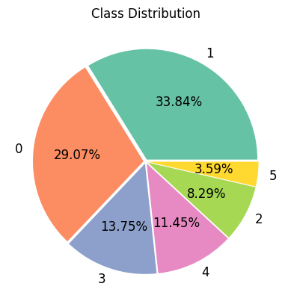
Fig. 3 Class distribution
Table 2 Sample text
Labels | Emotions | Sample Text
4 | Fear | I stood before my newly rebuilt bike looking across the field i had to ride feeling very apprehensive
0 | Sadness | I feel less and less burdened or bothered by both the past and my present day to day challenges
2 | Love | I watch the film i feel sympathetic for all the characters
1 | Joy | I feel so many artistic motivations that is hard to keep them to myself
5 | Surprise | I’m feeling a bit amazed and grateful about having landed amid such a congregation
3 | Anger | I’ve been feeling so cranky and why so many others around me are so cranky

4.2. Recognition Results on Emotion Dataset 1
Table 3 depicts the training and testing phases performance of TERLLMV-DLN technique on Emotion Dataset 1 under numerous metrics. Under 70%TRPHE, the proposed TERLLMV-DLN approach has gained an average $acc{ur}_{y}$, $pre{ci}_{n}$, $rec{al}_{l}, F_{Measure}$, and $MCC$of 99.08%, 97.25%, 97.25%, 97.25%, and 96.70%. Furthermore, under 30%TSPHE, the proposed TERLLMV-DLN methodology has accomplished average $acc{ur}_{y}$, $pre{ci}_{n}$, $rec{al}_{l}, F_{Measure}$, and $MCC$of 99.10%, 97.30%, 97.31%, 97.30%, and 96.77%.
Table 3 Training and testing phase outcome of the TERLLMV-DLN model on Emotion Dataset 1
Class Labels | $$Acc{ur}_{y}$$ | $$Pre{ci}_{n}$$ | $$Rec{al}_{l}$$ | $$F_{Measure}$$ | MCC
TRPHE (70%) | 99.08 | 97.25 | 97.25 | 97.25 | 96.70
TSPHE (30%) | 99.10 | 97.30 | 97.31 | 97.30 | 96.77

Fig. 4 signifies the classifier solution of the TERLLMV-DLN approach on Emotions Dataset 1. Fig. 4a reveals the analysis of PR, depicting the maximal outcome through every class. The figure portrays that the TERLLMV-DLN system constantly reaches greater rates of PR through diverse classes. Eventually, Fig. 4b portrays the average solution of the training phase 70% under several metrics.
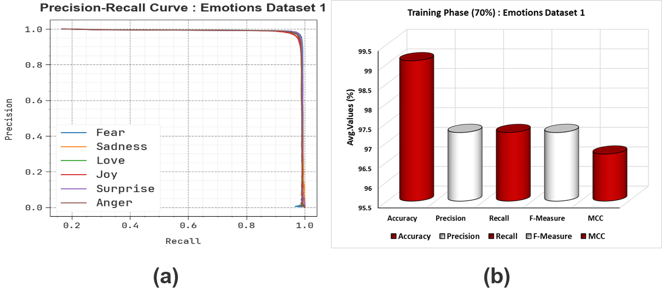
Fig. 4 Emotions Dataset 1 (a) PR curve and (b) 70% Training phase
Fig. 5 depicts the classifier solution of the TERLLMV-DLN model on Emotions Dataset 1. Fig. 5a demonstrates the analysis of ROC, representing capable results with superior rates of ROC for diverse classes. Finally, Fig. 5b represents the average result of the testing phase 30% under diverse metrics.
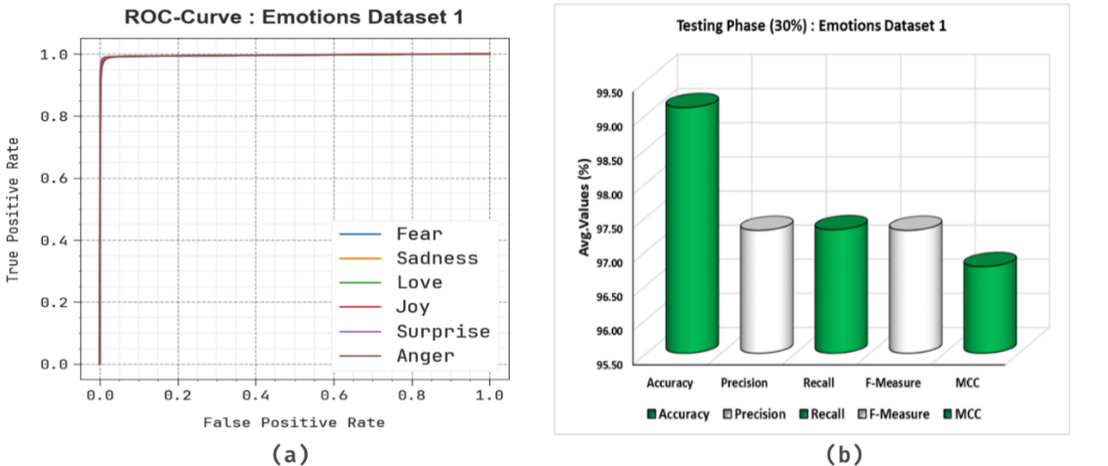
Fig. 5 Emotions Dataset 1 (a) ROC curve and (b) 30% Testing phase
Fig. 6 exposes the training (TRAN) and validation (VALD) accuracy of the TERLLMV-DLN technique on Emotions Dataset 1 over 25 epochs. Both curves progressively rise and slowly converge, which signifies that the model is learning effectually. The VALD accuracy constantly stays slightly greater than the TRAN accuracy, representing that the model is not overfitting and is generalising well to unseen data. The obtained results demonstrate the effectiveness of AI-driven perception models in accurately interpreting human emotions. This supports the broader applicability of the proposed approach within intelligent visual computing and interaction systems. The fluctuations in accuracy are expected owing to the intricacy of the task, but the entire upward tendency illustrates robust outcomes and steadiness of the model.
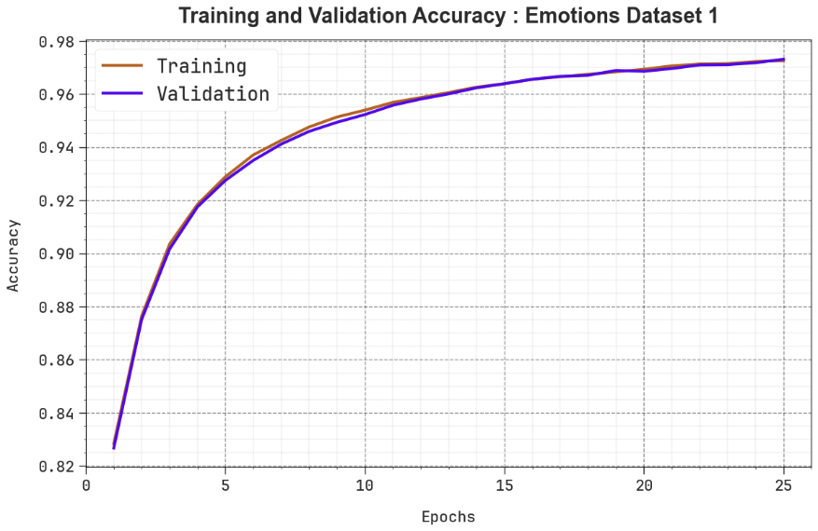
Fig. 6 $Acc{ur}_{y}$ curve of the TERLLMV-DLN technique on Emotions Dataset 1
Fig. 7 establishes the TRAN and VALD loss of the TERLLMV-DLN approach on Emotions Dataset 1 over 25 epochs. Both curves reveal a constant downward tendency, representing that the model is effectually decreasing error during learning. The VALD loss remains slightly lower than the training loss through most epochs, signifying better generality and no signs of overfitting. While some fluctuations are identified to become progressively reliable and stable.
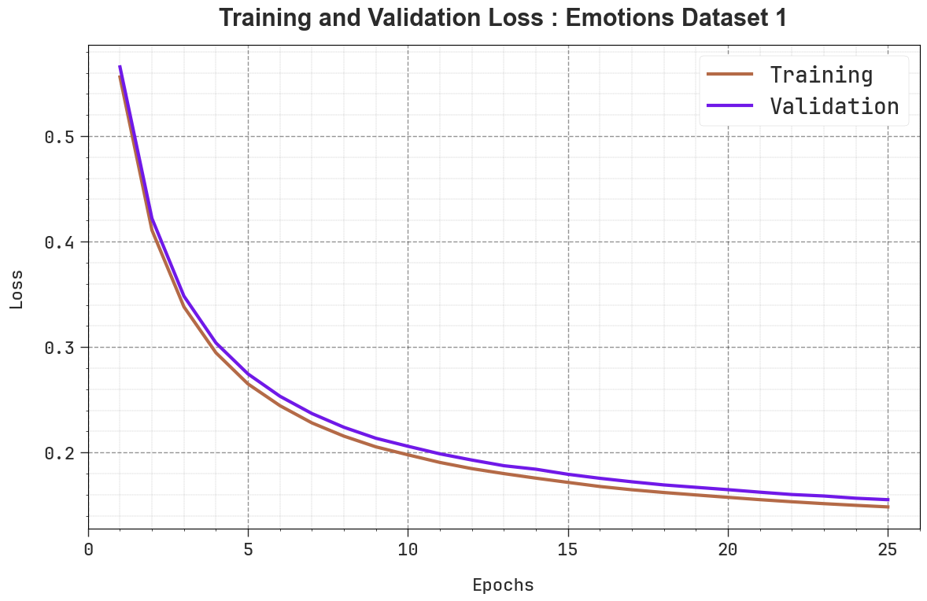
Fig. 7 Loss curve of the TERLLMV-DLN technique on Emotions Dataset 1
Table 4 and Fig. 8 denote the comparative analysis of TERLLMV-DLN technique on Emotion Dataset 1 with existing approach under numerous measures [31][32][33]. Depending on $acc{ur}_{y}$, the TERLLMV-DLN method has gained maximal $acc{ur}_{y}$ of 99.10% while the RoBERTa-base, SentiBERT, ResNet50-CRNN+AT, Bi-RNN, Improved DBN-SVM, AE-Bi-LSTM, and GAN methodologies have got minimal $acc{ur}_{y}$ of 69.55%, 78.34%, 79.17%, 80.51%, 88.31%, 86.52%, and 87.00%, correspondingly. At last, depend on $F_{Measure}$, the TERLLMV-DLN technique has gained superior $F_{Measure}$ of 97.30% whereas the RoBERTa-base, SentiBERT, ResNet50-CRNN+AT, Bi-RNN, Improved DBN-SVM, AE-Bi-LSTM, and GAN techniques have gained smaller $F_{Measure}$ of 90.25%, 95.93%, 83.35%, 93.56%, 92.85%, 82.38%, and 82.75%, correspondingly.
Table 4 Comparative outcome of TERLLMV-DLN on Emotion dataset 1
Emotion Dataset 1
Frameworks | Accuracy | Precision | Recall | F-Measure
Roberta-base | 69.55 | 81.17 | 88.12 | 90.25
Senti BERT | 78.34 | 96.77 | 93.26 | 95.93
ResNet50-CRNN+AT | 79.17 | 82.83 | 95.75 | 83.35
Bi-RNN | 80.51 | 95.74 | 90.88 | 93.56
Improved DBN-SVM | 88.31 | 92.57 | 81.28 | 92.85
AE-Bi-LSTM | 86.52 | 95.87 | 95.17 | 82.38
GAN Model | 87.00 | 82.32 | 87.62 | 82.75
TERLLMV-DLN | 99.10 | 97.30 | 97.31 | 97.30

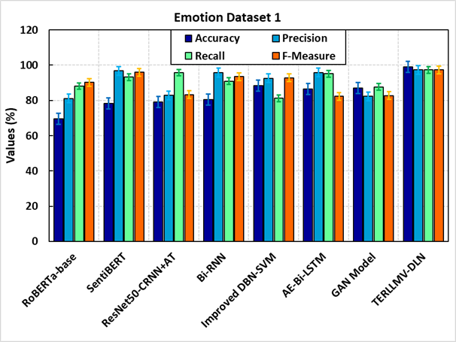
Fig. 8. Comparative analysis of the TERLLMV-DLN model on Emotion dataset 1
Table 5 represents the ablation study of the TERLLMV-DLN model with existing methods on Emotion Dataset 1. Depend on $acc{ur}_{y}$, the TERLLMV-DLN (Ensemble Learning strategy with LLM text vectorization) method has accomplished maximal $acc{ur}_{y}$ of 99.10% although the TCN+LLM (with text vectorization process without SDAE and ENN), SDAE+LLM (with text vectorization process without TCN and ENN), and ENN+LLM (with text vectorization process without SDAE and TCN) models have got lower $acc{ur}_{y}$ of 97.10%, 97.84%, and 98.38%, correspondingly. Furthermore, depending on $pre{ci}_{n}$, the TERLLMV-DLN (Ensemble Learning strategy with LLM text vectorization) technique has achieved $pre{ci}_{n}$of 97.30% while the TCN+LLM (with text vectorization process without SDAE and ENN), SDAE+LLM (with text vectorization process without TCN and ENN), and ENN+LLM (with text vectorization process without SDAE and TCN) methodologies have got lower $pre{ci}_{n}$ of 95.35%, 96.07%, and 96.79%, respectively. Eventually, depending on $F_{Measure}$, the TERLLMV-DLN (Ensemble Learning strategy with LLM text vectorization) technique has reached a superior $F_{Measure}$ of 97.30% whereas the TCN+LLM (with text vectorization process without SDAE and ENN), SDAE+LLM (with text vectorization process without TCN and ENN), and ENN+LLM (with text vectorization process without SDAE and TCN) models have attained a minimal $F_{Measure}$of 95.21%, 95.98%, and 96.69%, respectively.
Table 5 Ablation study of TERLLMV-DLN model on Emotion Dataset 1
Emotion Dataset 1
Frameworks | $$Acc{ur}_{y}$$ | $$Pre{ci}_{n}$$ | $$Rec{al}_{l}$$ | $$F_{Measure}$$
TCN+LLM (with text vectorization process without SDAE and ENN) | 97.10 | 95.35 | 95.36 | 95.21
SDAE+LLM (with text vectorization process without TCN and ENN) | 97.84 | 96.07 | 95.93 | 95.98
ENN+LLM (with text vectorization process without SDAE and TCN) | 98.38 | 96.79 | 96.69 | 96.69
TERLLMV-DLN (Ensemble Learning strategy with LLM text vectorization) | 99.10 | 97.30 | 97.31 | 97.30

4.3. Description of Emotion Dataset 2
This dataset comprises 40,000 text samples distributed through a variety of emotion classes. The largest portions of the data belong to Neutral (8,638 samples) and Worry (8,459 samples), followed by Happiness (5,209 samples) and Sadness (5,165 samples). Other emotions such as Love (3,842), Surprise (2,187), Fun (1,776), Relief (1,526), and Hate (1,323) have moderate representation. Simultaneously, emotions like Empty (827), Enthusiasm (759), Boredom (179), and especially Anger (110) are underrepresented, exposing substantial imbalance. Overall, dataset covers an extensive emotional spectrum, the uneven distribution through classes recommends that care should be taken during training and evaluation to prevent techniques from being biased toward the more frequent emotions. Table 6 denotes the sample text. Fig. 9 signifies the count plot for sentiments.
Table 6 Sample text
Emotions | Sample Text
Enthusiasm | “I want another tatt”
Neutral | “I can't give @jertronic any bday nudges.”
Worry | “Is sad that shin ae got married...and it wasn't to alex”
Hate | “Would wish the severe migrains would stop!!! doc's prescriptions aren’t working”
Fun | “RIP Leonardo. You were a great mini fiddler crab”
Boredom | “I’m so tired”
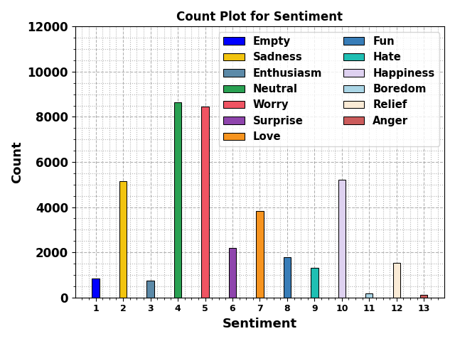
Fig. 9 Count plot for sentiments
4.4. Recognition Results on Emotion Dataset 2
Table 7 demonstrates the training and testing phase solutions of the TERLLMV-DLN technique on Emotion Dataset 2 under diverse metrics. Under 70%TRPHE, the proposed TERLLMV-DLN approach has gained average $acc{ur}_{y}$, $pre{ci}_{n}$, $rec{al}_{l}, F_{Measure}$, and $MCC$of 98.93%, 81.67%, 73.90%, 75.53%, and 75.84%, correspondingly. Besides, under 30%TSPHE, the proposed TERLLMV-DLN technique has accomplished an average $acc{ur}_{y}$, $pre{ci}_{n}$, $rec{al}_{l}, F_{Measure}$, and $MCC$of 98.90%, 80.41%, 74.00%, 75.25%, and 75.40%, correspondingly.
Table 7 Training and testing phase outcome of TERLLMV-DLN model on Emotion Dataset 2
Class Labels | $$Acc{ur}_{y}$$ | $$Pre{ci}_{n}$$ | $$Rec{al}_{l}$$ | $$F_{Measure}$$ | MCC
TRPHE (70%) | 98.93 | 81.67 | 73.90 | 75.53 | 75.84
TSPHE (30%) | 98.90 | 80.41 | 74.00 | 75.25 | 75.40

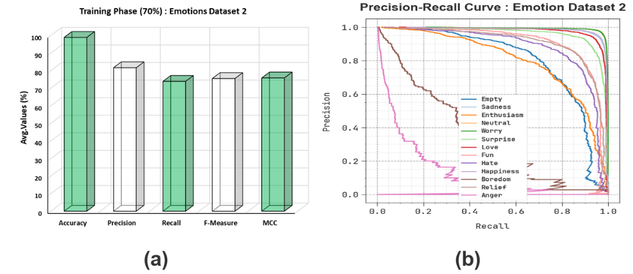
Fig. 10 Emotions Dataset 2 (a) PR curve and (b) 70% Training phase
Fig. 10 portrays the classifier solutions of TERLLMV-DLN approach on Emotions Dataset 2. Fig. 10a shows the analysis of PR, representing maximal solution through every class. The outcomes reveal that the TERLLMV-DLN approach constantly reaches enhanced values of PR through diverse classes. At last, Fig. 10b demonstrates the average performance of the training phase 70% under numerous metrics.
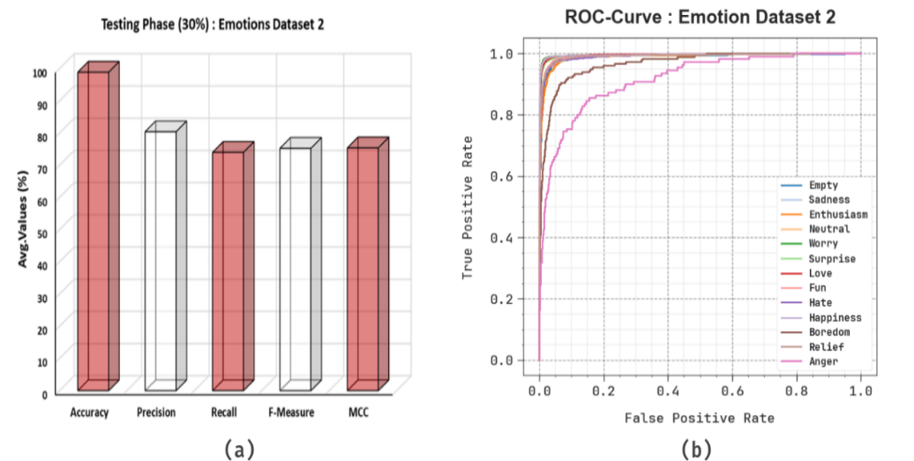
Fig. 11 Emotions Dataset 2 (a) ROC curve and (b) 30% Testing phase
Fig. 11 signifies the classifier performance of the TERLLMV-DLN model on Emotions Dataset 2. Fig. 11a depicts the analysis of ROC, indicating capable solutions with maximal values of ROC for diverse classes. Finally, Fig. 11b portrays the average performance of testing phase 30% under several metrics.
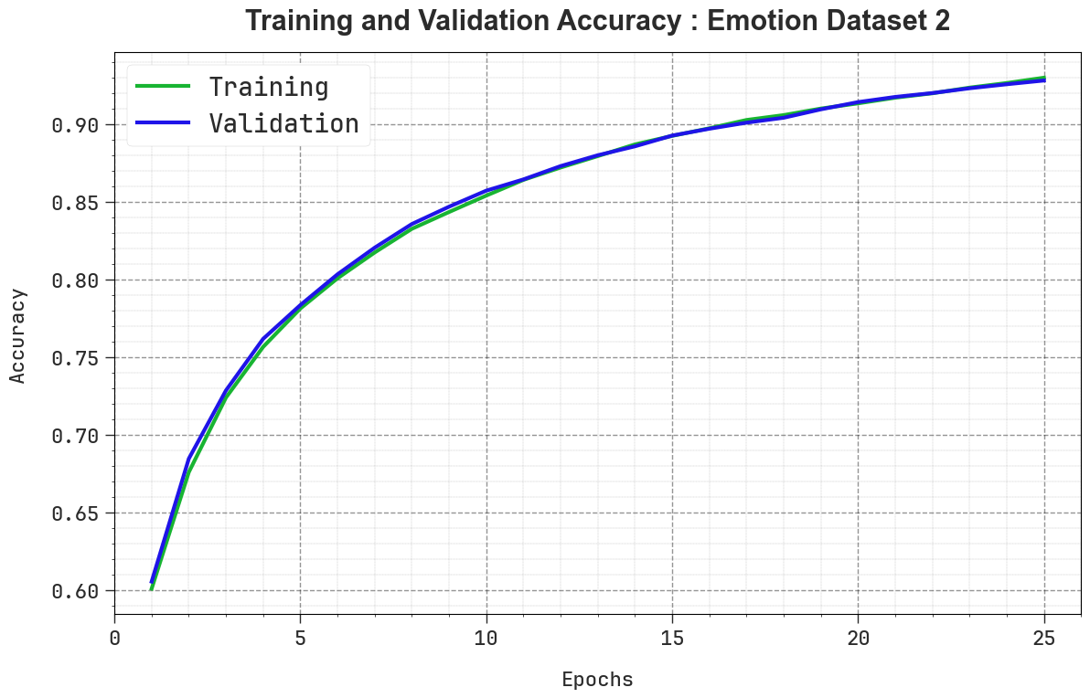
Fig. 12 $Acc{ur}_{y}$ curve of the TERLLMV-DLN technique on Emotion Dataset 2
Fig. 12 reveals the TRAN and VALD accuracy of the TERLLMV-DLN technique on Emotion Dataset 2 over 25 epochs. Both curves progressively rise and steadily converge, which signifies that the model is learning effectually. The VALD accuracy constantly stays slightly greater than the TRAN accuracy, recommending that the model is not overfitting and is generalizing well to unseen data. The fluctuations in accuracy are expected owing to the difficulty of the task, but the whole upward tendency establishes an enhanced outcome and steadiness of the model.
Fig. 13 denotes the TRAN and VALD loss of TERLLMV-DLN technique on Emotion Dataset 2 over 25 epochs. Both curves reveal a constant downward tendency, representing that the model is effectually decreasing error during learning. The VALD loss remains slightly lesser than the training loss through most epochs, recommending better generality and no signs of overfitting. At the same time, some fluctuations are identified to become progressively reliable and stable.
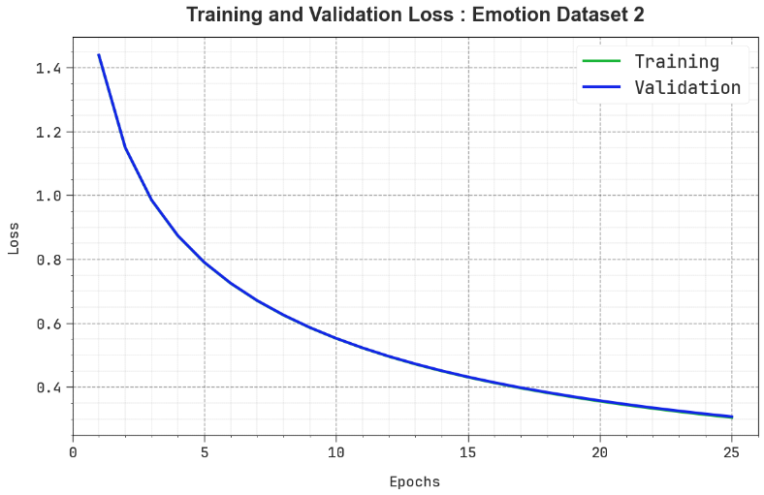
Fig. 13 Loss curve of the TERLLMV-DLN technique on Emotions Dataset 2
Table 8 and Fig. 14 present the comparison solution of the TERLLMV-DLN methodology on Emotion dataset 2. The solutions emphasized that the GPT-4-FS, EmoBART, BiMER, BiLSTM+CNN, Bi-GRU, XLNet, and VGGish Slow Fast approaches have stated worse outcome. Meanwhile, the TERLLMV-DLN approach stated enhanced outcome with highest $acc{ur}_{y}$, $pre{ci}_{n}$, $rec{al}_{l}$and $F_{Measure}$ of 98.93%, 81.67%, 73.90%, and 75.53%, correspondingly.
Table 8 Comparative analysis of the TERLLMV-DLN approach under Emotion Dataset 2
Emotion Dataset 2
Frameworks | $$Acc{ur}_{y}$$ | $$Pre{ci}_{n}$$ | $$Rec{al}_{l}$$ | $$F_{Measure}$$
GPT-4-FS | 80.34 | 66.83 | 70.38 | 70.85
EmoBART | 89.22 | 76.48 | 73.43 | 70.62
BiMER | 88.33 | 79.25 | 70.91 | 68.03
BiLSTM+CNN | 81.20 | 70.37 | 65.22 | 69.98
Bi-GRU | 81.10 | 79.76 | 67.32 | 71.87
XLNet | 85.11 | 72.34 | 72.30 | 69.34
VGGish Slow Fast | 87.00 | 70.27 | 68.07 | 67.71
TERLLMV-DLN | 98.93 | 81.67 | 73.90 | 75.53

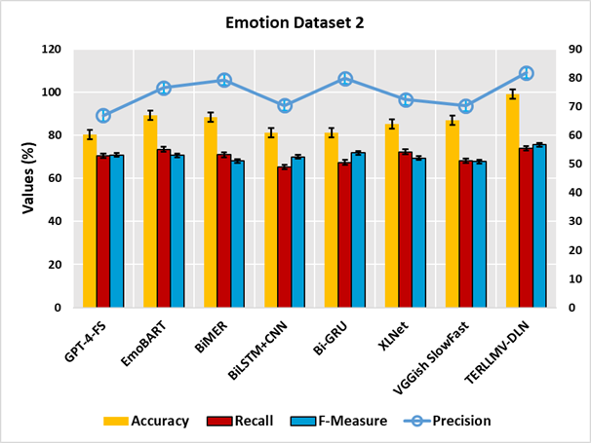
Fig. 14 Comparative analysis of the TERLLMV-DLN model on Emotion Dataset 2
Table 9 represents the ablation study of the TERLLMV-DLN model with existing methods on Emotion Dataset 2. Depend on $acc{ur}_{y}$, the TERLLMV-DLN (Ensemble Learning strategy with LLM text vectorization) model has gained maximal $acc{ur}_{y}$ of 98.93% while the TCN+LLM (with text vectorization process without SDAE and ENN), SDAE+LLM (with text vectorization process without TCN and ENN), and ENN+LLM (with text vectorization process without SDAE and TCN) methods have got minimal $acc{ur}_{y}$ of 96.82%, 97.48%, and 98.23%, correspondingly. Moreover, depending on $the pre{ci}_{sion}$, the TERLLMV-DLN (Ensemble Learning strategy with LLM text vectorization) system has achieved a superior $pre{ci}_{n}$ of 81.67% while the TCN+LLM (with text vectorization process without SDAE and ENN), SDAE+LLM (with text vectorization process without TCN and ENN), and ENN+LLM (with text vectorization process without SDAE and TCN) methods have achieved lower $pre{ci}_{sion}$ of 79.49%, 80.22%, and 81.01%, respectively. Eventually, depending on $F_{Measure}$, the TERLLMV-DLN (Ensemble Learning strategy with LLM text vectorization) technique has accomplished a greater $F_{Measure}$ of 75.53% whereas the TCN+LLM (with text vectorization process without SDAE and ENN), SDAE+LLM (with text vectorization process without TCN and ENN), and ENN+LLM (with text vectorization process without SDAE and TCN) techniques have reached lower $F_{Measure}$of 73.67%, 74.33%, and 74.88%, respectively. These results confirmed that the inclusion of ensemble process helps in attaining enhanced recognition performance.
Table 9 Ablation study of the TERLLMV-DLN model on Emotion Dataset 2
Emotion Dataset 2
Frameworks | $$Acc{ur}_{y}$$ | $$Pre{ci}_{n}$$ | $$Rec{al}_{l}$$ | $$F_{Measure}$$
TCN+LLM (with text vectorization process without SDAE and ENN) | 96.82 | 79.49 | 71.75 | 73.67
SDAE+LLM (with text vectorization process without TCN and ENN) | 97.48 | 80.22 | 72.44 | 74.33
ENN+LLM (with text vectorization process without SDAE and TCN) | 98.23 | 81.01 | 73.15 | 74.88
TERLLMV-DLN (Ensemble Learning strategy with LLM text vectorization) | 98.93 | 81.67 | 73.90 | 75.53

5. Conclusion
In this manuscript, we have presented the TERLLMV-DLN model for disabled individuals. The purpose of the proposed TERLLMV-DLN model is to offer a precise and socially impactful solution for emotion recognition in accessibility-focused applications. To attain this, the proposed TERLLMV-DLN algorithm utilises a comprehensive text preprocessing stage comprising numerous steps designed to improve input data and maintain linguistic consistency. Then, an LLM is employed in the text vectorization process to create high-dimensional semantic vectors. Finally, an ensemble learning strategy is employed by integrating three powerful models, namely TCN, SDAE, and ENN, to improve recognition accuracy. A broad range of simulation investigations is carried out to guarantee the enhanced performance of the TERLLMV-DLN model. The study contributes to the advancement of AI-enabled perception and analysis, which are key components of contemporary visual computing research. The proposed framework highlights the potential of integrating learning models for human-centered intelligent systems. The comparative outcome implied the improvement of the TERLLMV-DLN model on recent approaches concerning diverse evaluation metrics.

Declarations:
Acknowledgments
The authors acknowledge all the subjects and survey staﬀs who participated in the study.
Data Availability
The data that support the findings of this study are openly available in Kaggle repository at https://www.kaggle.com/datasets/bhavikjikadara/emotions-dataset and https://www.kaggle.com/datasets/pashupatigupta/emotion-detection-from-text, reference number [29, 30].
Conflicts of Interest
The author declares that he has no conflict of interest.
Funding Statement
Not Applicable.
Author Contribution
The authors contributed to this study as follows: Amani Abdulrahman Albraikan and Nasser Allheeib conceptualized the research idea and designed the study framework. Malak Bakheet Alharbi and Salihah Alotaibi were responsible for data collection, preprocessing, and preliminary analysis. Jahangir Khan and Haidar Almubarak carried out the formal analysis, methodology development, and interpretation of results. Hanadi Alkhudhayr contributed to literature review, validation, and manuscript drafting. Abdulbasit A. Darem supervised the overall project, provided critical revisions, and finalized the manuscript for submission. All authors reviewed and approved the final version of the manuscript.
Ethical Approval
The study was supported by all participants and approved by the Yuhuan Second People's Hospital Ethics Committee.
Consent to Participate
Not applicable.
Consent to Publication
All authors have provided consent for publication of this manuscript.
Competing Interests
The authors declare no competing interests

References
- Kushwaha A (2024) AI and non-verbal communication: enhancing understanding of emotional cues for children with hearing impairment. In: Transforming Learning: The Power of Educational Technologies, p 13.
- Shende RH, Shaikh NF Machine learning and deep learning paradigms in sign language recognition for the hearing impaired: a comprehensive review. SSRN. https://doi.org/10.2139/ssrn.5018867
- ZainEldin H, Gamel SA, Talaat FM, Aljohani M, Baghdadi NA, Malki A, Badawy M, Elhosseini MA (2024) Silent no more: a comprehensive review of artificial intelligence, deep learning, and machine learning in facilitating deaf and mute communication. Artificial Intelligence Review 57(7):188. https://doi.org/10.1007/s10462-024-10816-0
- Shahira KC, Sruthi CJ, Lijiya A (2022) Assistive technologies for visual, hearing, and speech impairments: machine learning and deep learning solutions. In: Fundamentals and Methods of Machine and Deep Learning: Algorithms, Tools and Applications, pp 397–423. https://doi.org/10.1002/9781119821908.ch17
- Marzouk R, Alrowais F, Al-Wesabi FN, Hilal AM (2022) Atom search optimization with deep learning enabled Arabic sign language recognition for speaking and hearing disability persons. Healthcare 10(9):1606. https://doi.org/10.3390/healthcare10091606
- Ates Ö, Pandey G, Gousiopoulos A, Soldatos TG (2024) A brief reference to AI-driven audible reality (AuRa) in open world: potential, applications, and evaluation. Frontiers in Artificial Intelligence 7:1424371. https://doi.org/10.3389/frai.2024.1424371
- Asiri MM, Motwakel A, Drar S (2023) Enhanced bald eagle search optimizer with transfer learning-based sign language recognition for hearing-impaired persons. Journal of Disability Research 2(3):86–93. https://doi.org/10.55879/jdr.2023.2.3.86
- Mack KA, Qadri R, Denton R, Kane SK, Bennett CL (2024) “They only care to show us the wheelchair”: disability representation in text-to-image AI models. In: Proceedings of the CHI Conference on Human Factors in Computing Systems, pp 1–23. https://doi.org/10.1145/3613904.3642166
- Tanabe H, Shiraishi T, Sato H, Nihei M, Inoue T, Kuwabara C (2024) A concept for emotion recognition systems for children with profound intellectual and multiple disabilities based on artificial intelligence using physiological and motion signals. Disability and Rehabilitation: Assistive Technology 19(4):1319–1326. https://doi.org/10.1080/17483107.2023.2170478
- Guo A, Kamar E, Vaughan JW, Wallach H, Morris MR (2020) Toward fairness in AI for people with disabilities: a research roadmap. ACM SIGACCESS Accessibility and Computing. https://doi.org/10.1145/3386296.3386298
- Li M, Jung Y, Song S, Kim J (2025) Attention-driven visual emphasis for medical volumetric image visualization. Vis Comput 41(5):3205–3219. https://doi.org/10.1007/s00371-024-03596-9
- Song W, Wang X, Jiang Y, Li S, Hao A, Hou X, Qin H (2024) Expressive 3D facial animation generation based on local-to-global latent diffusion. IEEE Trans Visual Comput Graphics 30(11):7397–7407. https://doi.org/10.1109/TVCG.2024.3456213
- Di Luzio F, Rosato A, Panella M (2025) An explainable fast deep neural network for emotion recognition. Biomedical Signal Processing and Control 100:107177. https://doi.org/10.1016/j.bspc.2024.107177
- Selim MM, Assiri MS (2025) Enhancing Arabic text-to-speech synthesis for emotional expression in visually impaired individuals using the artificial hummingbird and hybrid deep learning model. Alexandria Engineering Journal 119:493–502.
https://doi.org/10.1016/j.aej.2025.02.011
- Han B, Yau C, Lei S, Gratch J (2024) Knowledge-based emotion recognition using large language models. In: Proceedings of the International Conference on Affective Computing and Intelligent Interaction (ACII), pp 1–9. https://doi.org/10.1109/ACII63134.2024.00005
- Jha SK, Suvvari S, Kumar M (2024) Emotion recognition from electroencephalogram (EEG) signals using a multiple column convolutional neural network model. SN Computer Science 5(2):213. https://doi.org/10.1007/s42979-023-02543-0
- Ding Y, Tong C, Zhang S, Jiang M, Li Y, Lim KJ (2025) EmT: A Novel Transformer for Generalized Cross-Subject EEG Emotion Recognition. IEEE Trans Neural Netw Learn Syst 36(6):10381–10393. https://doi.org/10.1109/TNNLS.2025.3552603
- Alshahrani HM, Yaseen I, Dear S (2023) Textual emotion analysis-based disabled people talking using improved metaheuristics with deep learning techniques for intelligent systems. Journal of Disability Research 2(3):40–47. https://doi.org/10.55879/jdr.2023.2.3.40
- Machová K, Szabóová M, Paralič J, Mičko J (2023) Detection of emotion by text analysis using machine learning. Frontiers in Psychology 14:1190326. https://doi.org/10.3389/fpsyg.2023.1190326
- Hussain M, AboAlSamh HA, Ullah I (2023) Emotion recognition system based on two-level ensemble of deep-convolutional neural network models. 11:16875–16895. https://doi.org/10.1109/ACCESS.2023.3245830
- Vasamsetty C, Kadiyala B, Alavilli SK, Nippatla RP, Boyapati S (2025) Impact of Artificial Intelligenc e on Geriatric Clinical Care for Chronic Diseases: Integrating Time-Series Analysis, Wearable Health Devices, CDSS, Medical Image Analysis, and Voice-Based Diagnostics. J Soft Comput Paradigm 7(1):1-16. https://doi.org/10.36548/jscp.2025.1.001
- Wang T, Hou B, Li J, Shi P, Zhang B, Snoussi H (2023) TASTA: Text-assisted spatial and temporal attention network for video question answering. Adv Intell Syst 5(4):2200131. https://doi.org/10.1002/aisy.202200131
- Zhao H, Ji T, Rosin PL, Li YK, Meng WL, Wang YN (2024) Cross-lingual font style transfer with full-domain convolutional attention. Pattern Recognit 155:110709. https://doi.org/10.1016/j.patcog.2024.110709
- Khariroh S, Alzami F, Indrayani H, Dewi IN, Marjuni A, Adriani MR, Subowo MH (2025) Implementation of LSA for topic modeling on tweets with the keyword ‘Kemenkeu’. Sinkron 9(1):129–148. https://doi.org/10.33395/sinkron.v9i1.14309
- Huang Z, Long Y, Peng K, Tong S (2025) An embedding-based semantic analysis approach: a preliminary study on redundancy detection in psychological concepts operationalised by scales. Journal of Intelligence 13(1):11. https://doi.org/10.3390/jintelligence13010011
- Zhao Q, Li H, Zhang Q, Wang Y (2025) A Study on Metal Futures Price Prediction Based on Piecewise Cubic Bézier Filtering for TCN. Appl Sci 15(17):9792. https://doi.org/10.3390/app15179792
- Moradzadeh A, Amjady N, Massoud AM, Shah R, Al-Emadi N, Muyeen SM (2025) A new deep federated learning model with high generalizability for electrical load forecasting against data integrity attacks. Results in Engineering:107246. https://doi.org/10.1016/j.rineng.2025.107246
- Mou X, Huang X, Ma G, Luo Q, Yang X, Xin S, Wan F (2025) Prediction of storage quality and multi-objective optimization of storage conditions for fresh Lycium barbarum L based on optimized Latin hypercube sampling. Foods 14(16):2807. https://doi.org/10.3390/foods14162807
- Emotions dataset (2023) Kaggle. https://www.kaggle.com/datasets/bhavikjikadara/emotions-dataset
- Emotion detection from text dataset (2023) Kaggle. https://www.kaggle.com/datasets/pashupatigupta/emotion-detection-from-text
- Liu Z, Yang K, Xie Q, Zhang T, Ananiadou S (2024) EmoLLMs: a series of emotional large language models and annotation tools for comprehensive affective analysis. In: Proceedings of the ACM SIGKDD Conference on Knowledge Discovery and Data Mining, pp 5487–5496. https://doi.org/10.1145/3637528.3671552
- Dikbiyik E, Demir O, Dogan B (2025) BiMER: Design and Implementation of a Bimodal Emotion Recognition System Enhanced by Data Augmentation Techniques. IEEE Access 13:64330–64352. https://doi.org/10.1109/ACCESS.2025.3559339
- Jiang X, Zhang Y, Lin G, Yu L (2024) Music Emotion Recognition Based on Deep Learning: A Review. IEEE Access 12:157716–157745. https://doi.org/10.1109/ACCESS.2024.3484470

